 | “Oh my god, did you see that?” or: Abjection, L’informe & simulacra in contemporary art
Capstone | Katherine Huddle-Parker

In this essay, I will discuss the vague, ambiguous and confusing theories and philosophies of four of the 20th century’s greatest writers, philosophers and critics: Georges Bataille on the informe, Rosalind Krauss on Bataille’s informe and abjection, Julia Kristeva on the abject and Jean Baudrillard on Simulacra and Simulation. Multiple, varying images will be analyzed using these theories. Through photography, painting, sculpture, installation, and video art I will analyze how these particular works relate to either or both of the ideas of the abject or the informe. Moreover, I will examine how contemporary critics, such as those associated with the 1993 Whitney Museum Show on the abject and the Formless: A User’s Gudie show from Rosalind Krauss and Yves-Alain Bois on the Informe have helped to shape and define what we now categorize as abject and informe art, even if those boundaries, as contemporary art moves forward through the decades, have become increasingly blurred. Furthermore, I will explore how major themes in art, including: women, bodies, death, birth, food, and murder, are all overarching content for many works included in both L’informe and abjection, thus connecting the two concepts even more. What's more, I aim to prove that many of the following works of art can be read as cross-categorizational: capable of being in more than one of the three categories at once, which include abjection, l’informe and simulacra.
The informe challenges the categories of what we have now termed in art history high art, such as line, space, shape, value, color and texture. This basically means that everything you learned in grade school art class about balance and symmetry are thrown out the window by thinkers such as George Bataille and Jean Baudrillard. In his novel Simulacra and Simulations, Baudrillard states that ‘the proof of art through anti-art’ can be established, which is very similar in thinking to Bataille in that the informe brings art back down to the ground, and is in essence considered low art. Bataille once said that pleasure ‘only starts once the worm has got into the fruit, to become delightful happiness must be tainted with poison.’ This statement, along with Bataille’s interest in the realms of pain and pleasure, as seen in his essay The Tears of Eros, helps to establish a background for the creation of the idea of the informe. The materials customarily associated with the informe include dirt, tangles, jumbles, piles, and other various messes.
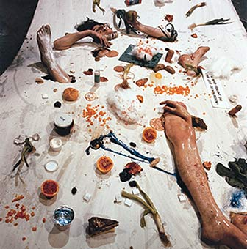
One of the ideas behind the informe is that of Bataille’s base materialism. Base materialism includes ‘matter that disrupts the opposition of high and low and destabilizes all foundations,’ such as heterogeneous matter. Base Materialism was included as part of the 1993 Whitney Abject show as one of four main categories of formlessness, two of which stemmed from Bataille, including base materialism. Rosalind Krauss and co-curator Yves Alain-Bois selected pieces to fill the criteria for this category, which included works from artists such as Robert Rauschenberg and Cindy Sherman.
Heterogenous matter, and indeed the aspect of scatter, mess, and trash, all parts of the informe, can be observed in the work of artist Otto Muhl. Muhl was for a time part of the Vienna Action Group, and during this time created a strange mixture of performance/action/happening that was then filmed and photographed entitled Nahrungsmittletest (1966.)
Image 1: Otto Muhl, ‘Nahrunsgmittletest,’ 1966.
In Nahrungsmittletest, two dark haired nude young women are covered with a large rectangular shaped blanket on the floor. They are lying down and appear as if they are touching feet to feet; however, the glistening, moist legs and feet are hardly seen and instead pop out through random assorted holes in the material. There are random pieces of food scattered about in haphazard, messy way. The juiciest bits of the informe are presented: cotton ball fluff, junk and trash in total disarray on the ground with no apparent meaning to the order, or in this case, disorder. It is these that are the leftover bits that are tremendously problematic in terms of classification. When Bataille suggested that we think of the sun as a ‘solar anus,’ perhaps we should consider this human appendage, food and trash wasteland collage as a ‘sisterly picnic’ instead of the murderous undertones implied by the scattered limbs and blood spatter like patterns created by the crumbles of old food. The overall project of the actionists, which included an interest in Freudian psychotherapy and analysis, is evident here in the theme and content of the work, which can be traced back to the writings of Julia Kristeva and her work on the Abject, connoting that this piece of art could be considered both abject and informe. Aside from the theories of Kristeva and Bataille, there is also Jean Baudrillard, who believed that all of ‘human experience is of a simulation of reality.’ He believed that the society that we are currently living in is completely comprised of the hypperreal, which means that the images we see are in fact more real themselves than the actual objects they are depicting. The reality behind the images no longer exists in the hyperreal, or in postmodernity, and thus meaning falls apart. He created four stages of order in which images can be placed to in respect to their ‘reality.’ The following abject and formless images include symbols pertaining to death, life, birth, and femininity, which are symbols that Baudrillard believed have constructed our society as we know it. Since all meaning is made meaningless due to the ever-changing nature of meaning, I believe it is this meaninglessness, and perversion of reality, that coincides well with art of the abject and informe – particularly those works that feature super photorealistic painting. Taking this in to consideration, piece could fit in to either the second or third stages of simulacra. The reason why I am hesitant to place this piece firmly in to one or the other is that it is unclear whether this is merely a perverted version of a true reality, or whether this is a copy of reality that has no true original. This event, or happening that was associated with the event, might have been an original, real event.
Image 2: Justin Gignac, ‘Garbage of New York City.’
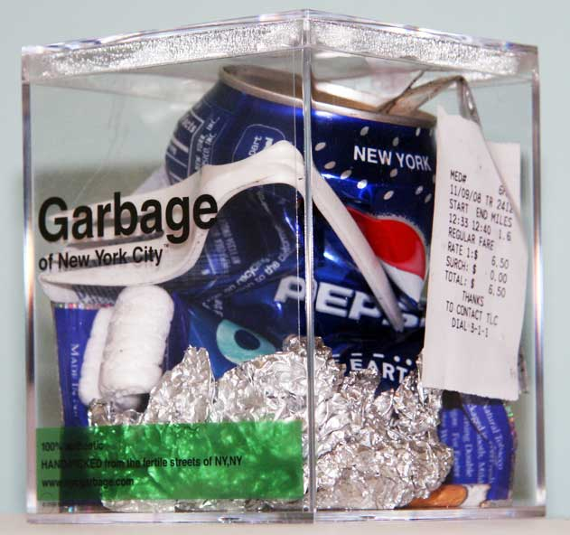
Another artist who works with trash, refuse and ‘leftovers’ is Justin Gignac, who collects trash from the streets of New York to collect his eclectic pieces, such as Garbage of New York City. Arranged inside clear display boxes, the content of each is different: empty and crushed soda cans, old grocery lists, shopping receipts, McDonald’s wrappers, Starbucks cups, and everything and anything you could find on the streets of New York, including used condoms and drug paraphernalia. It is as Julia Kristeva said in her essay the Power of Horror: “It is thus not lack of cleanliness or health that causes abjection, but what disturbs identity, system, order. What does not respect borders, positions, rules. The in-between, the ambiguous, the composite. These pieces upset the identity of those whose trash this used to be when it was not considered ‘trash.’ They also defy the order of what typically has been considered art or gallery worthy: they are the ‘leftovers’ of a consumerist society, and as trash, are thus extremely undesirable. Garbage of New York City is also associated with the first stage of Baudrillard’s simulation, in which the symbols are a ‘reflection of a profound reality’ in that they are garbage taken straight from the streets of a dirty, dingy city and openly displayed in a gallery space.
Image 2: Justin Gignac, ‘ Garbage of New York City.’
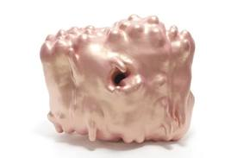
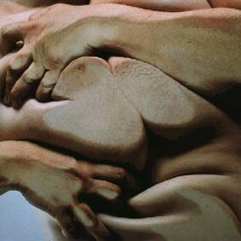
The abject work of the British painter Jenny Saville explores the grotesque side of the female body and flesh. While some body parts are still distinguishable, Saville renders the already abject female body even more abject through its abstractedness: the viewer is unsure of whether it is truly seeing a female nude, a blob of amorphous skin, or something else entirely. The female flesh, which Saville so voluptuously renders, is related to Kristeva’s maternal abjection and our need to reject our mothers in order to become separate entities. Saville herself sees a childhood reference in her work: “…the closer they get to the painting, it's like going back into childhood. “ The grotesque, metamorphoses images of feminine bodies disturbs what the viewer has traditionally thought of as a perfect, ideal feminine body, pushing them away from the boundary between themselves and their mothers. Kristeva’s theory of abjection contains the necessary quality of separating oneself from the unwanted. This separation is here made evident with the unwanted, unaesthetic fat body that is repulsive to look at. We thus distance ourselves from this ‘other,’ and abject it. In reference to Baudrillard’s stages of Simulacra and Simulation, I firmly believe that this image belongs in the first stage, as it is a faithful copy of a real image, despite it appearing to be ‘perverted,’ due to the fact that this is an accurate portrayal of the human body.
Image 3: Jenny Saville, ‘Closed Contact.’
The ambiguous that Kristeva speaks of can be seen with the sculptures of Ken Price. Eezo is a giant pink blob that undulates in its ovalesque form. It is slightly metallic in color, with a bright sheen and a pearl like coating. It is somewhat sexual both in the organic shape, color and circular hole in the middle of the form that could be construed as an anal reference, harkening back to Bataille’s interest in the anus, once even referred to himself as the ‘excremental philosopher.’ It could also be construed as a body part that has been deformed, or as the subject of a mutation: a vagina exposed to radiation. It is hard to categorize and is relatively meaningless to the beholder.
Image 4: Ken Price, ‘Eezo.’
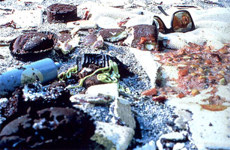
The work of Cindy Sherman is also difficult to fit into a single category of abjection, informe or simulation. While her work was included as part of the catalog for the 1993 Whitney Museum show on the abject, she also has created other pieces that could be construed as formless. In Untitled #175 (1987), the mess that has been created shows the leftover of the informe, as well as base materialism in the materials. Additionally, there is a general sense of post- calamity or acccident. What appears to be vomit on the right side of the image, along with the reflected appearance of what appears to be a dead or inebriated woman in the sunglasses above the vomit produces a menacing scenario in this set up. Food loathing is also at play here with the smashed, damaged chocolate cupcakes on the opposite side of the vomit. This image, aside from evoking tones of murder, could also symbolize eating disorders, which are traditionally associated with women, hence the food, vomit and reflection of a woman. Here, the theme of food, bodies, women and substances are used to create a piece of photographic abjection that attacks the viewer’s sensations of what has been lost in the vomit. Quoting Laura Mulvey, the feministic theorist from her essay on Cindy Sherman and abjection, Krauss notes: “Although both sexes are subject to abjection, it is women who can explore and analyze the phenomenon with greater equanimity, as it is the female body that has come, not exclusively but predominantly, to represent the shudder aroused by liquidity and decay.” Untitled #175 fits into the third stage of Baudrillard’s theory, wherein the image displayed has no original source, and the symbols inside the image, in this case the assortment of sunglasses, food items and human substances, could potentially have, on the surface, no inherent relationship whatsoever. One particular female abject artist whose works can be analyzed from both an informe and abject perspective is Monica Cook. She is a painting working in super hyper photo-realism concerning food pornography. In The Powers of Horror, Kristeva noted that ‘food loathing is perhaps the most elementary and archaic form of abjection.’ While the imagery mostly depicts women seemingly enjoying their close relationship with food, it appears to the viewer to have negative connotations. Sprouting Potatoes (2009) is oil on canvas with three women as the main subject. There are two naked women, seen from the waist up, who stand exuberantly over a table. Splayed across this table is a woman clothes in a beige, sheer garment. She is disemboweled and lying horizontally beneath the two nude women. This image hauntingly echoes the still lives of Vermeer: grapes, peeled orange slices, pomegranates broken open, and a multitude of various fruits are thrown about in a tight group around the body lying on the table. The naked woman, who encompasses the left of the picture plane, is covered in a tan colored goop that is rolling down her arms and her exposed right breast.
Image 5: Cindy Sherman, “Untitled #175.”
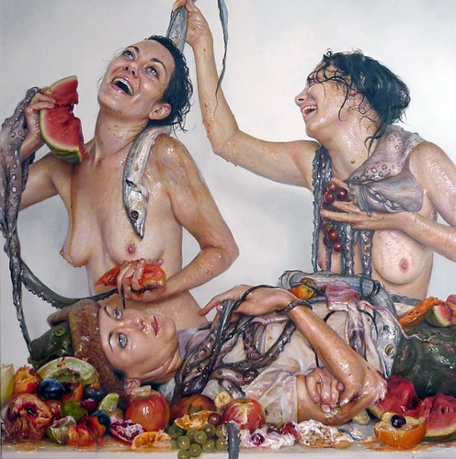
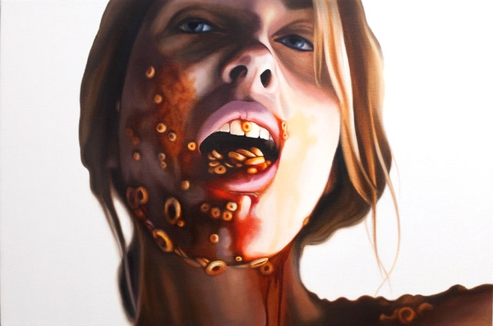
Rosalind Krauss, author of a more recent book on informe, Formless: A User’s Guide, or as it has been described by some of its readers, Useless: A Formal Guide, has also written on the concept of sliminess and goop in her article Informe Without Conclusion: “To grasp forms of matter as ontological conditions ultimately relates the metaphysical purport of sliminess to the way the autonomous subject is compromised by this substance.” Thus, we should not be sickened so much by the slimy substances seen on these women, but what the sliminess represents. Here it could reference the ‘blood’ of the woman that has been disemboweled on the table. She continues with the views of Jean Paul Sartre on this topic, and how he viewed sliminess as ‘feminine-yielding, clinging, sweet, passive, [and] possessive.’ The open expression of female eroticism can be considered part of Bataille’s base materialism with the naked female forms. The transgressions, or taboos, of base materialism can include this piece being read as overt lesbianism, murder, cannibalism, or a combination of all three. There is a dead fish being draped over her left shoulder by her naked companion. She is holding a half-eaten piece of watermelon in one hand and octopus like tentacles encircle her wrist. The woman next to her has tentacles draped across her shoulders as if they were a fine fur, and she clutches a cluster of grapes in her hand. Dead fish and rotting fruit are everywhere. The imagery evokes feelings of murderous intent, conspiracy and the grotesque. Succi (2009) is rather comparable to Sprouting Potatoes. What appears to be a mass of twisted bodies in an orgy confronts us with twisting legs, arms, partially exposed breasts and nipples, asses, and strange disembodies human limb. If the horizontality of art considered informe aids the artist in breaking down formal barriers, then this goes a step further by eliminating any perspective or sense of horizontal or vertical line. Cook effectively eliminated the phallic vertical line and creates a jumbled, organic sphere of shapes and objects instead. Tentacles and fruit add to the erotic and dangerous undertones of this piece. In this piece, as with Sprouting Potatoes, there are bits of light that reflect off of body parts and fruit, making the scene look all too realistic. Kristeva believes that ‘light as the gaze,’ or ‘wild light, or gleams’ such as these serve as a ‘kind of luminous dispersal that is not unlike what Jacques Lacan described as Gaze.’ She goes on to say that the scattered light, ‘which sometimes takes the form of highlights on bits of flesh or fabric…are luminous but dispersive, [and] this Gaze thus works against the Gestalt, against form.’ It is seen through this type of work how such small elements can assist in breaking down barriers of formal high art through the abject and informe.
Image 6: Monica Cook, “Sprouting Potatoes,” 2009.
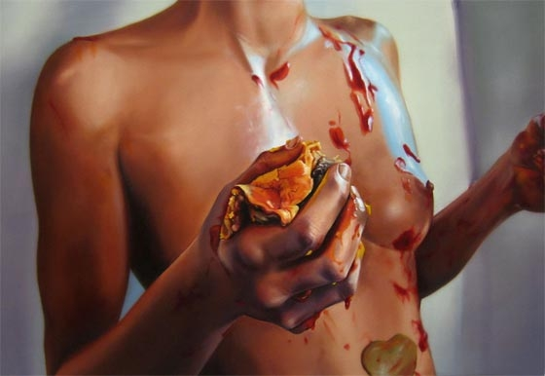
Categories and barriers are correspondingly broken down in the work of artist Emily Burns, whose paintings are full of qualities of abjection and l’informe. Monica, a portrait of a young woman, is made grotesque by the addition of Spaghetti-O’s slathered on her face, dripping down here neck, pooling around her shoulders and dangling out of her mouth. The red spaghetti sauce looks eerily similar to blood, and the gaze on the woman is not of fear or pain, but nearly happiness or ecstatic. This image could also be read as having to do with women and eating disorders. The line between object and subject, and indeed the feminine internal and external body is crossed here when the viewer witnesses a process having to do with either the intake or expulsion of food from the body. This image, as well as the headless nude below, also relate to Kristeva’s food loathing as a form of abjection. In (title), the faceless woman’s exposed breast is covered with the leftover remnants of a blood orange colored substance, most likely ketchup, and in the woman’s right hand she grasps the decaying, used up form of a hamburger. The glistening, blood red substance on the woman’s chest, hands and breast can be viewed as both abjection and base materialism in that the ‘blood’ color could reference the blood of childbirth and breastfeeding fluids, while the light reflecting off of the woman’s naked, nubile body and its associated materials add to the formlessness of the piece. The hamburger the woman is holding can be read as symbolic for the woman as a piece of meat in a sexist, consumerist society. Extremely similar to the work of Cook, the feminine body, already considered abject by society, here again is made even more abject by the addition of food substances, mess, and the leftover. This image is also a superior example of the simulacra, or hyperreal, of Baudrillard. The food fluids and substances, in terms of Baudrillard, act to ‘mask and pervert a basic reality’ of a woman covered in food. The trauma caused in the viewer by viewing substances that were once part of their own bodies, such as food, and are now outside of the body, such as blood or vomit, become abject, and the shock of the viewer that results is an abject experience which places the viewer in a liminal state.
Image 7: Emily Burns, “Monica,” 2010.
Image 8: Emily Burns, “Burger,” 2008.
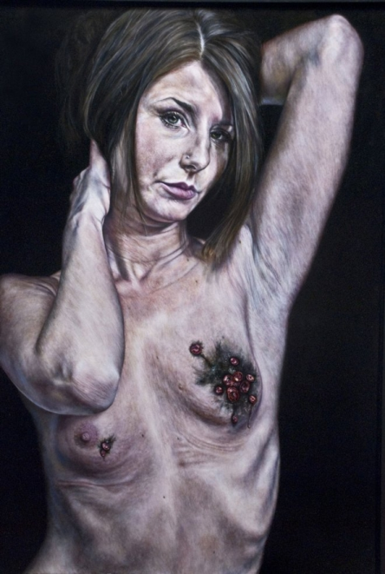
In local Hoosier artist Amanda Elizabeth Joseph’s work, which is quite similar to that of both Cook and Burns in content and appearance, the idea of the feminine abject is also explored. A rough, haggardly looking young woman has been drawn nude, with her arms lifted up above her head. She is shockingly thin to the point where her ribs are clearly visible. A feeling of sickness and death surrounds the female nude character, whose exposes breasts and nipples are blackened and covered in small, ruby red rhinestones. If this is to be read as a breast cancer victim, or even a victim of abuse, even self-abuse, then the idea that this woman has been ‘marked’ by disease and the addition of rhinestones only adds to her identity as a cast-aside ‘other.’
Image 9: Amanda Elizabeth Joseph, “Glitter Plague.”
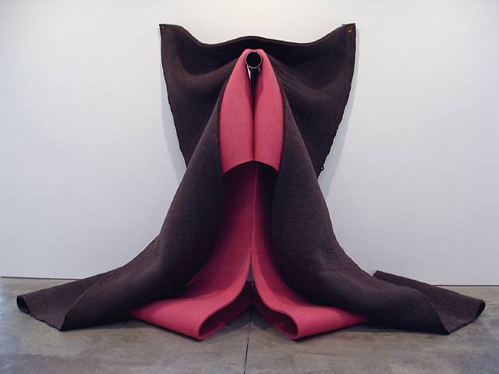
Sculptural artist Robert Morris’ scrap felt creations, like VETTI III (1983), a large scale purple and pink vertically draped, free flow ‘dangling’ installation piece invokes the erotic with its organic vagina like shape. The purple and pink colors are feminine and add to the overall feminine aesthetic. The leftover scraps and trash have here been used to create what seems like a 3D representation of a Georgia O’Keefe painting. It is overtly sexual but has a slightly comedic appearance. Its mere large size subverts the object it represents through its enlargement, making the object of birth and women’s sexuality an object in itself. In Baudrillard’s words, ‘it is a question of substituting the signs of the real for the real.’ Pieces such as this were selected for the Formless: A User’s Guide show based on the processes involved in creating the art, such as with the work of Claes Oldenburg’s Sculpture in the Form of a Fried Egg, which had its verticality reduced even more by the curator’s placement of the piece on the floor, such as how Morris’ Vetti was hung from the wall.
Image 10: Robert Morris, ‘VETTI III,’ 1983.
Image 10: Robert Morris, ‘VETTI III,’ 1983.
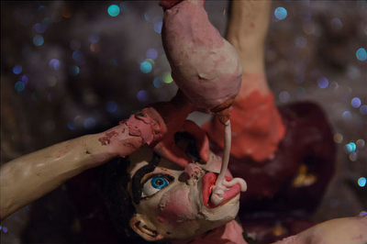
Women’s bodies are also featured in the work of video artist Nathalie Djurberg, whose 2009 video installation The Experiment (Cave) from 2009 is one of the finest and simultaneously most unsettling short Claymation films in recent years. It is a combination of installation, Claymation, digital video and mixed media. The video starts out with a claymation creation of a female with dark hair who resembles your typical Barbie doll in the face. It is there, however, that the similarity to your childhood friend ends. A dark cave environment surrounds the figure. Kristeva, quoting Proust, describes a similar abject environment: ““…in those regions that were almost slums, what a modest existence, abject, if you please…” The cave could be considered a slum to this vulnerable figure. This work is more abject than anything previously discussed herein. Kristeva believes that the abject ‘is related to perversion,’ but this work goes beyond perversion.
Image 11: Still, Natalie Djurberg, “The Cave,” 2009.
Image 10: Robert Morris, “VETTI III,” 1983.
Image 11: Still, Natalie Djurberg, “The Cave,” 2009.
The clay figure has an aesthetically pleasing face, but the stomach and pubic areas are grossly enlarged. The anonymous female character’s ass is also engorged and not correctly proportionate to the rest of her slim body. She lies down on the rocks of the floor of the cave and her arms proceed to seemingly rip themselves free of her body. Her arms then work to free her legs from her body by tearing them off, as well. The viewer witnesses the arms and legs shoving a long white strand of toilet paper up the figure’s anus. The character is visibly upset and shocked, but her own hand places itself over her mouth, muting her screams. It is as if her own body is raping her. What is truly unnerving is the moment when her detached hand strokes her face and lightly caresses her breast. The hand continues to shove the paper up the character’s anus. The arms remove her breast, shove it in her face, plug her nose with her fingers and force her to drink her own breast milk. The installation surrounding the video screen included large scale, dead, decaying and oozing flowers. Hair-raising circus music from Hans Berg pushes the piece forward in ominous tones. The viewer is left wondering if this woman is the victim of self-hegemony, a play on the cultural hegemony of Antonio Gramsci. Is she being dominated not by a differing social class, but by her own body? This piece is abject in both psychological and carnal means, from the rape scene to the blood emanating from the woman’s missing limb wounds.
Image 12: Still, Natalie Djurberg, “The Cave,” 2009.
Another video artist whose work features strange renditions of the human body is Ofek Wertman. Faces is informe in its dissolution of the human body. Through the nearly ten minutes of mind bending imagery, you see a quickly morphing and evolving grouping of bodies and parts: two arms, three eyes, an eye in the middle of a stomach, six bellybuttons on one torso, pubic hair, eyebrows, two breasts, six breasts, one breast, countless faces. Superimposed faces on top of faces and miscellaneous body parts. At times, it is even difficult to discern which body parts are male and which are female. Near the end, the body imagery turns into geometric imagery: a jumble that acts as a signifier for the informe.
I believe that Kristeva’s opinion on the abject and literature can apply to art, and specifically this piece: "On close inspection, all literature is probably a version of the apocalypse that seems to me rooted, no matter what its sociohistorical conditions might be, on the fragile border (borderline cases) where identities (subject/object, etc.) do not exist or only barely so—double, fuzzy, heterogeneous, animal, metamorphosed, altered, abject.” It is the merging and blending of imagery without any apparent meaning, identifiable persons or content aside from just the bodily forms and creations that make this abject. As curator Helen Molesworth said in an interview with Rosalind Krauss, “Informe allows for slippage where at certain moments you can’t tell the difference between an eye and an asshole.” This applies for Wertman’s psychedelic video and the paintings of Monica Cook and Jenny Saville.
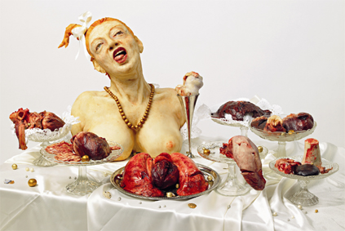
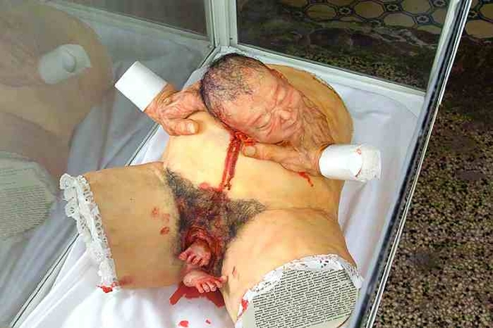
Women and body parts, two important aspects of Abject art, are featured in the work of food artist Helga Petrau-Heinzel, who created grotesque pieces including women and internal organs out of marzipan. A female nude bust sits atop a dining table with a white tablecloth. She has her mouth open wide and tongue hanging out to on side; her head is titled and she has a sweet white bow in her ponytail. Her bronze colored ball shaped necklace is her only other adornment, and is in great contrast to the organic shapes of the organs displayed and piled up on silver and glass trays around the bust. Hearts, lungs, spleens, kidneys and other various organs are delicately and heavily detailed in bright reds and burgundies. Body organs are also exposed in her more recent piece from 2011, Cesarian. What appears to be every new mother’s worst nightmare has been carefully sculpted in marzipan. The sizeable, swollen abdomen of a woman is displayed in a glass case. Placed on its back, the sculpture lacks a head, chest or limbs, yet there are small portions of the thighs attached to the torso. Hands are placed on either side of the distended stomach, but they appear far too timeworn and wrinkled to belong to the body of the smooth skinned sculpture. The head of a newborn baby is emerging from the stomach of the female sculpture, while its legs are budding from the bloodied, decimated vagina. This image relates more to abjection than formlessness. The theme of birth and the substance of blood link it to the abject, and also explore the liminal physical and emotional states of being born/being unborn, being a mother and being childless. This is also an example of the third stage of Baudrillard’s Simulacra since the objects in the sculpture - the infant’s head and feet, are positioned in uncommon locales: it would appear as if this child is being born body part by body part. These disassociated objects could not realistically emerge from a human body in such a manner. The unfamiliar placement of the emerging tot's body parts connotes something unnatural, and a typical childbirth scene has been here rendered incongruous and eerie.
Image 14: Helga Petrau-Heinzel, ‘Cesarian.’
Image 13: Helga Petrau-Heinzel, ‘Fresslust.’
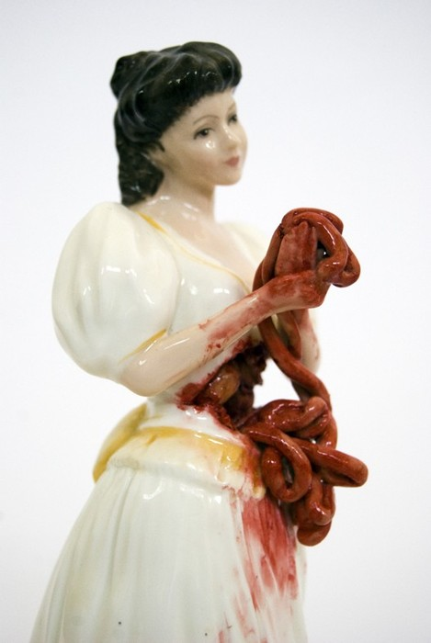
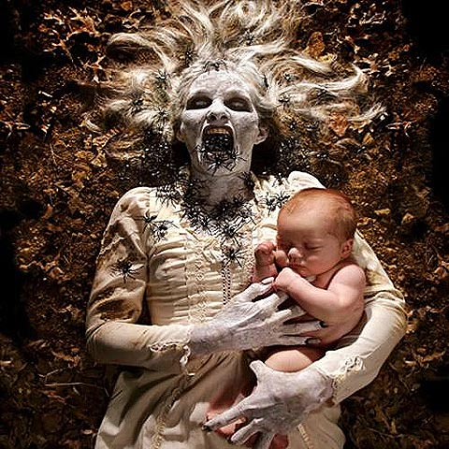
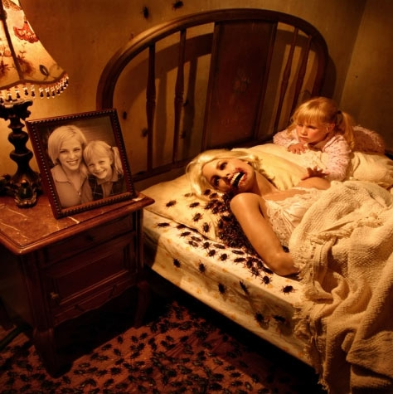
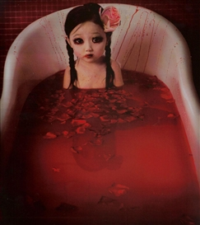
Body parts also emerge from the stomachs of other sculptures, particularly in Jessica Harrison’s tiny porcelain statue Rosamund also involves women with organs in a more solid medium. Her statuettes, on first glance, appear to feature characters straight out of a Disney fairytale: pale, perfect skin, ebony hair, pristine white gown, except, wait, she’s not holding a bouquet of freshly picked wild flowers - - it’s her intestines! This piece is more abject than informe. Rosalind Krauss sees the abject in much art that features violence and women: “The abject, understood as this undifferentiable maternal lining-a kind of feminine sublime, albeit composed of the infinite unspeakableness of bodily disgust: of blood, of excreta, of mucous membranes-is ultimately cast, within the theorization of abject art, as multiple forms of the wound. because whether or not the feminine subject is actually at stake in a given work, it is the character of being wounded, victimized, traumatized, marginalized, that is seen as what is in play within this domain. “ Joshua Hoffine’s horror photography features women that are seemingly victimized and marginalized. In Childhood Fears, a young, concerned child lies next to her dead, cockroach covered mother in bed. Next to the death bed, a portrait of the mother and child, then alive, adds to an increasing meta-ness about the piece, which can be related to Baudrillard’s hyperreal: we are viewing a false photograph inside a staged photograph. Again, the idea of abjection, particularly that of rejecting the maternal to become a separate entity, is at play here. The themes of death, life, motherhood, liminal states, and life attempting to distance itself from the maternal abject are prevalent in the horror photographs of Hoffine, as in much abject art. Jean Baudrillard’s ‘simulation’ is at play here, especially with the quote from Baudrillard on how ‘simulation threatens the difference between the “true” and the “false,” the “real” and the “imaginary.” Childhood Nightmares is also an example of formlessness in terms of base materialism and the dirt that surrounds a young zombie mother clutching her sleeping, live baby. A dead body is abject, but can it not also be considered part of Bataille’s ‘leftover’? We place our dead in cemeteries because they are undesirable and we deliberately exclude them from society. Therefore, this disturbing photograph is not only abject, but partially formless, as well. It could also be included in Baudrillard’s second stage of Simulacra, in which the warped reality of an undead mother and living child are an ‘evil appearance, [and] the order of maleficence.’ This is also part of the second out of the three orders of simulacra because it is a corruption of reality – a mother could really be holding her sleeping child, but not an undead mother.
Image 15: Jessica Harrison, ‘Rosamund.’
Image 16: Joshua Hoffine, ‘Childhood Dream.’
Image 15: Joshua Hoffine, ‘Childhood Fears.’
Image 17: Joshua Hoffine, ‘Childhood Nightmare.’
Image 17: Joshua Hoffine, ‘Childhood Nightmares.’
Image 18: Zhang Peng, ‘Desiring Happiness…’
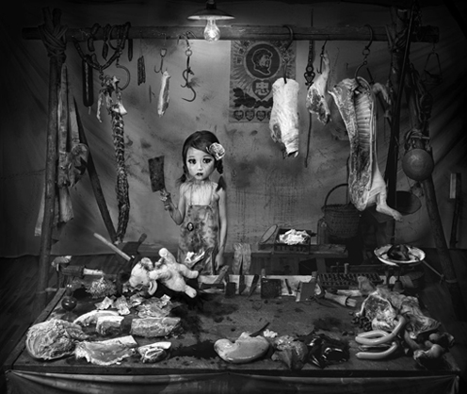
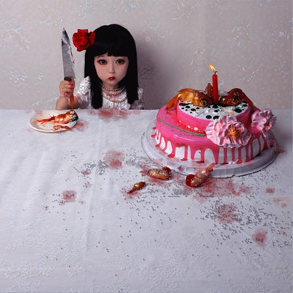
Women of all ages, including children, are subject to abject portrayals.. Zhang Peng’s photography at first seems like a series of pictures of his daughter, or portraits of small porcelain Asian dolls. On closer inspection, you see that these are something completely different...and monstrous. In Desiring Happiness No. 1, a delicate little girl is sitting in a bathtub with a miniature pink flower in her hair and childish pigtails. But, wait…there are dark circles around her eyes and specks of blood on her face. There are blood splatters around the small child on the back of the tub. There are red rose petals floating on the surface of the bright red blood filled horror of what might have occurred in this scene. We are left wondering what is lurking under the surface of the water/blood. Peng’s Goldfish is of the same child in her pretty white birthday dress. Again, she has a flower in her hair, typically indicating purity and virginity. She has strands of pearls that gleam off the blade of the knife she holds in her right hand. The blade has smears of blood and cake icing. Instead of a slice of birthday cake on her small plate, a dead goldfish sits instead. Mutilated goldfish are strewn about the table and are used as cake toppers. We see this small, precious child celebrating her birthday and we are flooded with safe and familiar emotions. However, seeing the same child in this new context causes a wave of confusing emotions that Kristeva would say are true feelings of abjection. “Any crime, because it draws attention to the fragility of the law, is abject, but premeditated crime, cunning murder, hypocritical revenge are even more so because they heighten the display of such fragility.” The blood, knives and murdered animals seen in Peng’s works are not as disturbing to us as the idea that a small child could accomplish these feats, or be subjected to such violence as seen in Happiness. This is also apparent in Peng’s more recent work, Made in China No. 2, in which the same young girl stands holding a large knife in a butcher shop scene, surrounding by large hunks of meat, animal carcasses, blood, and teddy bears.
Image 17: Zhang Peng, ‘Goldfish.’
Image 19: Zhang Peng, ‘Goldfish.’
Image 20: Zhang Peng, ‘Made in China No.2’
Image 20: Zhang Peng, ‘Made in China No..2’
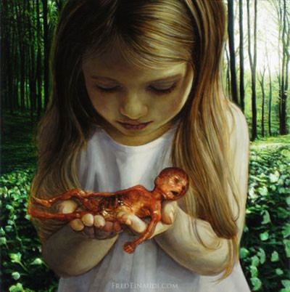
Halfway across the world, Fred Einaudi’s is likewise creating shocking works featuring young females. In his unsettling paintings, such as Homunculus, young women are depicted convincingly rendered, yet existing in uncommon and disturbing situations. Here, a young girl is in the foreground of a nature scene, surrounded by dark green hues of flowers, grass and trees. She gazes down at an object placed in her hands, wearing a serene expression. The child is not holding a bouquet of newly picked flowers or a kitten: it is a ghastly, premature fetus with exposed muscles, tendons, veins and blood. The scene evokes a maternal one, which is even more frightening because the young girl is obviously far too young to be a mother herself. It could also harken feticide or murder – perhaps she has murdered her future brother or sister. This could also be a scene reflecting an abortion, wherein the young girl is meant to portray the woman who is holding her aborted fetus, yet she feels childlike herself after the fact. This image hence denotes the Kristevan abjection of what has been made an abject ‘other’ – in this circumstance, the fetus – which has been cast aside. The title ‘homunculus’ could refer to the homunculus popular in medicine and science, a fully formed human being that is created through alchemical means. If this is the homunculus of this child, she could in fact, as if it were a clone, be staring at her own tiny form. It is a leftover, or the ‘other,’ and has been excluded by society, and even its own mother, creating a trauma in both the young girl/mother and the viewer.
Image 21: Fred Einaudi, ‘Homonculus,’ Oil on Canvas.
Image 19: Zhang Peng, ‘Made in China No.2.’
Image 19: Zhang Peng, ‘Made in China No.2.’
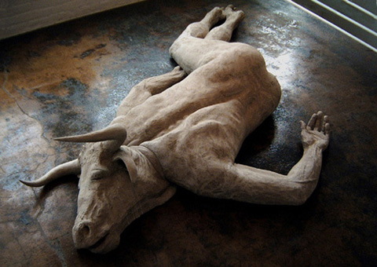
The last image that I would like to discuss comes from sculptor Emil Alzamora. Minotaur is a life-size bronze sculpture that is displayed on the floor of a gallery. The twisted, lifeless human body is agonizing for us to view, but when you add the head of a dead bull onto this perfectly well muscled and toned dead body, it is quite unnerving. While Kristeva states that the abject ‘confronts us…with those fragile states where man strays on the territories of animal,’ Minotaur also functions even more as abject art from the combination of a nimal and human and corpse. We are so traumatized and psychologically offended by the combination of animal and human and in its death, even more so: “The corpse, seen without God and outside of science, is the utmost of abjection. It is death infecting life. Abject. It is something rejected from which one does not part, from which one does not protect oneself as from an object. Imaginary uncanniness and real threat, it beckons to us and ends up engulfing us.” The mere placement of this sculpture, as opposed to the verticality associated with normal human beings, has been reduced to a horizontal, limp contortion of man-animal meat on the floor, which references Bataille’s base materialism. Indeed, many images have been included in the realm of the formless by their mere placement in a gallery setting, as seen with the work of fellow sculptural artist Mike Kelly in the 1995 formless show. In terms of Baudrillard’s simulacra, it is its own simulacra, or part of the fourth stage of simulacra; it is not based on any existing, known reality.
Image 22: Emil Alzamora, ‘Minotaur.’
While I have shown how many different contemporary artists incorporate aspects of the informe, simulacra and abjection into their works and can be read as such, the views of Kristeva, Bataille, Baudrillard and Krauss all differ somewhat in their approaches to each of these theories. In an interview with Krauss, Dennis Hollier, Yale University professor of French philosophy states that Bataille’s idea of the abject is difficult to grasp because it is not finished: “All the pages Bataille wrote under the heading of abjection were left unfinished; they were textual failures, published posthumously.” He even goes so far as to say, quoting from Bataille, that abject art ‘can not be shown.’ If we believe Hollier and in some cases Bataille, then that would make installations, gallery work, video and most art outside the realm of the abject: what is the purpose of art if not to share it with the world, to be seen? Kristeva’s abject is more about the physical and psychological, naming the particular substances, such as blood and corpses.
I loathe affirming this, but on this subject I actually agree with Rosalind Krauss and her interpretation of Bataille’s informe. I can see how the disgusting factors Kristeva’s abjection comes to play in many works of art, and how those factors then lower and debase the art, making it true abjection, but I prefer my informe and abjection in art when it is at its best: psychologically challenging. I would prefer ‘an informe that is not simply a question of form or structure or referentiality.’ Krauss has said that “the notion of the informe, as Bataille enunciates it, is about attacking the very imposition of categories, since they imply that certain forms of action are tied to certain types of objects.” The idea of anti-categories, or undoing categories, is similar to the liminal, in between states of Kristeva’s abject, and it is thus here that I believe these two categories are capable of being applied to certain works of art that have inherent qualities associated with the informe and abjection, particularly those that attack categories and explore boundaries. If this statement is true, then the informe succeeds as Bataille intended in the works of Nathalie Djurberg, in particular. We are used to different objects, if no objects at all, and different methods of placement, in anal sadism. Nonetheless, in The Experiment we see dislocated body parts of the own individual performing this task, and with an unknown substance. This attacks the traditional categories that women as sexualized objects are traditionally placed in fetish videos, and the material and medium of clay and video further break down those barriers, as video was traditionally a male realm.
Additionally, the application of Jean Baudrillard’s theory of the simulacra can help us to better understand these controversial art movement categorizations, or lack thereof, by examining them through the lens of Baudrillard’s four stages in relation to the simulacra. In art of the Abject and Informe, there exists an abject ‘liminal’ state in the viewer’s tactile experience, where, due to the themes portrayed in the art of this two movements, they are metaphorically encouraged to observe the realm of beyond reality, i.e. hyperreality, and are consequently capable of experiencing art that has no meaning in a more private manner.
I would like to leave with a quote again from Helen Molesworth on her goal for further informe and abject art and artists which I heartily anticipate for as well: “It seems to me the best that can be hoped for is that such work, abject or informe, might point to some transgressive place or practice – in a way that might, however momentarily, disturb the status quo.” While I firmly believe that many pieces of contemporary art contain elements that would categorize them in both the realms of abject and formless art, as well as the stages associated with Jean Baudrillard’s Simulacra and hyperreality, I also believe that applying French theory to these artistic creations helps us as art historians and viewers of art to think about the work and the overall themes that are illustrated in fresh, innovative methods. These approaches will ultimately assistant viewers, collectors, curators and historians alike to foster a more profound appreciation for, and understanding of, what has traditionally been deemed as unaesthetic, crude, unappealing, shocking, horrifying, pointless and vulgar: abject and informe art.

Baudrillard, Jean. Simulacra and Simulation. Trans. Sheila Faria Glaser. Ann Arbor: University of Michigan Press, 1994 (orig. 1981): 19.
Noys, Benjamin . "Georges Bataille’s Base Materialism." Cultural Values 2, no. 4 (1998): 499.
Baudrillard, Jean. Simulacra and Simulation. University of Michigan Press, 1994.
Kristeva, Julia. Powers of Horror: An Essay on Abjection . New York City: Columbia University Press, 1982: 4.
Krauss, Rosalind. “The Politics of the Signifier II: A Conversation on the ‘Informe’ and the Abject.” October 67 (1994): 3.
Kristeva, Julia. Powers of Horror: An Essay on Abjection . New York City: Columbia University Press, 1982: 2.
Krauss, Rosalind. ""Informe" without Conclusion." October 78, no. (1996): 92.
Krauss, Rosalind. ""Informe" without Conclusion." October 78, no. (1996): 92.
Krauss, Rosalind. ""Informe" without Conclusion." October 78, no. (1996): 8.
Baudrillard, Jean. Simulacra and Simulation. University of Michigan Press, 1994: 2.
Kristeva, Julia. Powers of Horror: An Essay on Abjection . New York City: Columbia University Press, 1982: 20.
Krauss, Rosalind. ""Informe" without Conclusion." October 78, no. (1996): 11.
Baudrillard, Jean. Simulacra and Simulation. University of Michigan Press, 1994: 6.
Krauss, Rosalind. ""Informe" without Conclusion." October 78, no. (1996): 5.
Kristeva, Julia. Powers of Horror: An Essay on Abjection . New York City: Columbia University Press, 1982: 4.
Krauss, Rosalind. “The Politics of the Signifier II: A Conversation on the ‘Informe’ and the Abject.” October 67 (1994): 5.
Krauss, Rosalind. “The Politics of the Signifier II: A Conversation on the ‘Informe’ and the Abject.” October 67 (1994): 20.
Krauss, Rosalind. “The Politics of the Signifier II: A Conversation on the ‘Informe’ and the Abject.” October 67 (1994): 21.

