What Study methods actually work?

How your study methods impact your long-term learning

Highlighting and underlining

rating: HOT GARBAGE
What is it?
When reading, you highlight or underline main ideas or important concepts.
Why does it work?
Well, it doesn’t work. Generally, there are two issues: 1) Most students are not good at picking out main ideas in the text, and 2) It’s a passive intake of information, which does not help with recall, testing, or understanding.
When should I use it?
Don’t rely on this as your only method. If you want to use it in conjunction with other methods, it may work better. But by itself? There’s a reason it’s earned the rating “hot garbage.”

Practice Testing

rating:
What is it?
Practicing recalling information, using flashcards, practice problems/questions, or practice test material provided by a textbook or professor.
Why does it work?
Taking a practice test forces you to actively recall and re-organize learned information. This method improves recall leaps and bounds over most other study methods. This also allows you to practice the activity of test-taking itself, which is its own skill. Generally, the most effective type of practice tests are short answer or free re-call tests, although all types of practice tests assist with memory. Even open book practice tests increase retention and learning.
When should I use it?
Doing regular practice tests is the best way to learn material and prepare for testing, no matter the subject. You don’t have to do a practice test every study session, but try to test yourself on material every few days. Even though this might be uncomfortable at first, the benefits to your grade will become clear as you utilize this method.

Distributed Practice

rating: Great
What is it?
Studying a little every day, rather than spending just a few days studying for consecutive hours.
Why does it work?
Forgetting is very important for long-term memory. Giving yourself a chance to forget information between study sessions means that the act of remembering again will imprint the information into your long term memory. By comparison, doing hours of studying at one time doesn’t give you any chance to forget before reviewing the material again, meaning that you’ll have to study for more hours to achieve the same result.
When should I use it?
Ideally, you would have the ability to study a little every day, but it’s understandable if life sometimes gets in the way. If you have a day full of classes and work, try to put aside 20 minutes to go over what you learned in class at the end of the day. On the days where you do have free time, study for only about 2 hours or so. This method will definitely require you to plan your week and assess what days you have the energy to study, but the results will be worthwhile.
Note: Make sure to take breaks!

Rereading

rating: Not Terrible
What is it?
After you’ve already read an article, textbook chapter, lecture notes, or other written information pertaining to your class, read it again. This works better with a delay of about four days between the first reading and the second.
Why does it work?
Reviewing material allows you to better organize it in your brain. You already know the content and main ideas, so you should pick up more information the second time. Because this effect is lost by the third re-reading, it is not recommended to go above a second time.
When should I use it?
This method does work, but other techniques generally work better. If this is the only method available to you, it’s not a waste of time.

Elaborative Interrogation

rating: GOOD
What is it?
Teaching others why or how aspects of the topic work. This could be a professor or fellow student. (Or maybe a pet/plant, if your audience is limited.)
Why does it work?
Asking “why” questions about material can help integrate existing knowledge with newly learned knowledge, boosting understanding and recall.
When should I use it?
It is best to use this technique when you already have a solid foundation of knowledge about a given subject. The more you already know, the easier it is to connect new material to your current understanding.

Self-Explanation

rating: GOOD
What is it?
Like the preceding method, this method focuses on the “why.” The difference is that you explain how you came to your own answer. The focus is your process, not necessarily the content.
Why does it work?
This method assists with the integration of new and old information. It can also help you self-assess by forcing you to examine your process. This indicates where you may be struggling with a problem or concept.
When should I use it?
This technique has been shown to work in a variety of contexts with a variety of students.

Summarization

rating: IT DEPENDS
What is it?
Taking information and putting it into your own words. You want to capture the main idea and important details pertaining to the topic. The key aspects is you should be directly relating ideas within the text to each other, and explaining how they integrate to form the larger take-away.
Why does it work?
Summarization helps you capture the main ideas of the topic, and connect ideas to each other explicitly. (It’s also good practice for essay-writing!)
When should I use it?
There are two general rules to writing summaries: 1) Quality matters; poorly done summaries will not help you learn the information, and 2) Use this when your assignments and tests are essay format, as this method is less helpful for multiple choice or problem-solving tests or assignments.

Key Word Mnemonic

rating: meh*
What is it?
Using your mind’s eye to generate images that will help you remember the concept you are attempting to learn.
Why does it work?
During testing, you can conjure up the associated image, and remember the “answer,” or thing you’re trying to memorize.
When should I use it?
Not every topic lends itself to this technique. There is also evidence that this technique doesn’t help establishing long term memories. After all, you’re learning a trick to memorize concepts, not increasing understanding.

Imagery Use for Text Learning

rating: It Depends*
What is it?
Creating images to match up with material that you read or learn.
Why does it work?
This may help your mental organization of ideas. It forces you to apply your knowledge and generate a cohesive narrative about the material.
When should I use it?
There are two criteria to maximize the usefulness of this technique: 1) It works better when you’re listening to the material, as opposed to reading it, and 2) It is shown to be more helpful with summarization rather than testing.

Interleaved Practice

rating: GOOD
What is it?
During a study session, mix up the types of problems you do. For example, when studying for math, you might combine problems from chapters 1-4 instead of only doing questions from chapter 4 by itself.
Why does it work?
When you study for only one section, you already have an idea of what kinds of problems you’re working on. When you mix up the types of problems or questions, it forces you to pull from the entire toolbox of skills you’ve learned from that subject. You can recognize differences and similarities in problems as you go through them, enhancing your understanding of the subject matter. You’ll be better able to identify how to solve each problem presented to you, or the variations across distinct topics.
When should I use it?
There are two situations where this method is best utilized: 1) Math or problem-solving questions or concepts, and 2) Comparing and contrast heavily, such as analyzing paintings from differing art styles or artists.

Quick Guide
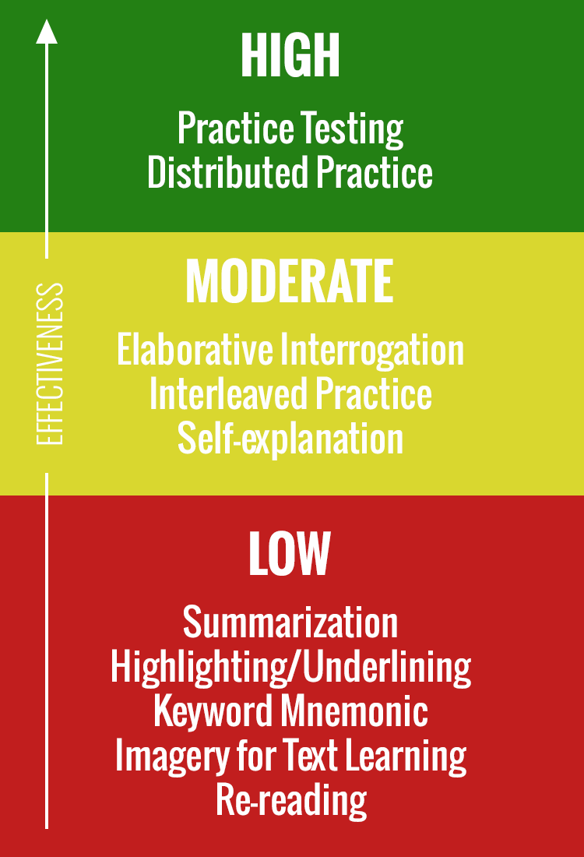
*Note: There are those without a mind’s eyes (aphantasia), or those with a very weak mind’s eye. Consider your own ability to visualize as an additional factor.

Citations
Dunlosky, J., Rawson, K. A., Marsh, E. J., Nathan, M. J., & Willingham, D. T. (2013). Improving Students’ Learning With Effective Learning Techniques: Promising Directions From Cognitive and Educational Psychology. Psychological Science in the Public Interest, 14(1), 4–58. https://doi.org/10.1177/1529100612453266

